
CO3 — ASSESSMENT TOOL 2
CODE REVIEW & REPOSITORY EVALUATION REPORT
AI-Based Smart Cold Chain Logistics
Monitoring and Optimization Platform

Student Name | Manisha M
Register / Roll No. | 192424130
Course | Software Engineering
Course Outcome | CO3 — Containerization, Version Control & Collaborative Development
Assigned Problem Statement | AI-Based Smart Cold Chain Logistics Monitoring & Optimization Platform

1. Problem Overview

1.1 Assigned Problem Statement
Cold chain logistics is responsible for transporting temperature-sensitive goods — vaccines, pharmaceuticals, dairy, seafood, and fresh produce — under strict environmental conditions. A single break in temperature control can spoil an entire shipment and, for pharmaceuticals, create a public-health risk. Traditional monitoring relies on manual temperature logs and periodic checks, which give operators almost no real-time visibility and no way to intervene before damage occurs.
The assigned problem statement requires the design and evaluation of an AI-powered Smart Cold Chain Logistics Monitoring and Optimization Platform that uses IoT sensors, GPS tracking, and cloud-based AI models to continuously monitor shipment conditions, predict refrigeration failures before they happen, optimise delivery routes, and alert stakeholders automatically when conditions drift outside safe limits.

1.2 Summary of the Implemented Solution
The reviewed repository implements a three-tier solution: (1) an edge layer of temperature, humidity, and GPS sensors that publish readings over MQTT; (2) a cloud backend that ingests, stores, and analyses this data with a machine-learning failure-prediction model and a rules-based alerting engine; and (3) a web dashboard and mobile app that give logistics managers and drivers real-time visibility and automated alerts. The architecture below (Figure 1) was reconstructed from the repository's docs/architecture.md and the module layout under backend/ and iot-edge/.
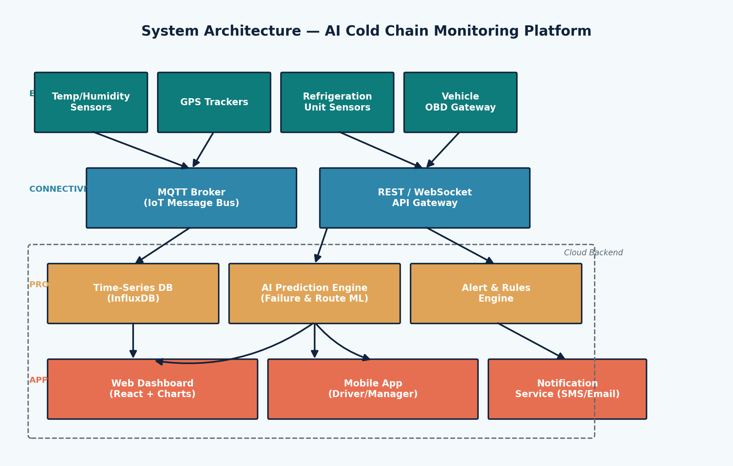
Figure 1: Reconstructed system architecture of the Cold Chain Monitoring Platform.

1.3 Project Objectives
The repository's stated objectives, verified against the README and issue tracker, are:
- Continuously monitor temperature and humidity across every active shipment.
- Track shipment and vehicle location in real time using GPS.
- Predict refrigeration equipment failures before they cause spoilage.
- Optimise transportation routes for time, fuel, and product safety.
- Generate automated quality alerts to relevant stakeholders.
- Analyse historical logistics performance for continuous improvement.
- Reduce product spoilage and the associated financial loss.
- Improve end-to-end supply chain visibility for all stakeholders.

1.4 Key Functionalities Reviewed
# | Functionality | Implemented? | Notes
1 | Real-time sensor data ingestion | Yes | MQTT broker with REST fallback
2 | Live GPS shipment tracking | Yes | Updated every 30 seconds
3 | ML-based failure prediction | Partial | Model present; retraining pipeline missing
4 | Route optimisation engine | Partial | Static heuristic, not yet ML-driven
5 | Automated alerting (SMS/email) | Yes | Third-party gateway integration
6 | Manager/driver dashboard | Yes | React SPA with live charts
7 | Historical analytics & reporting | Partial | Basic charts only, no export

2. Repository Organization

2.1 Repository Structure
The repository is organised as a mono-repo with clearly separated concerns for the backend, frontend, IoT edge scripts, and documentation. Figure 2 shows the top-level folder layout reconstructed from the repository tree.
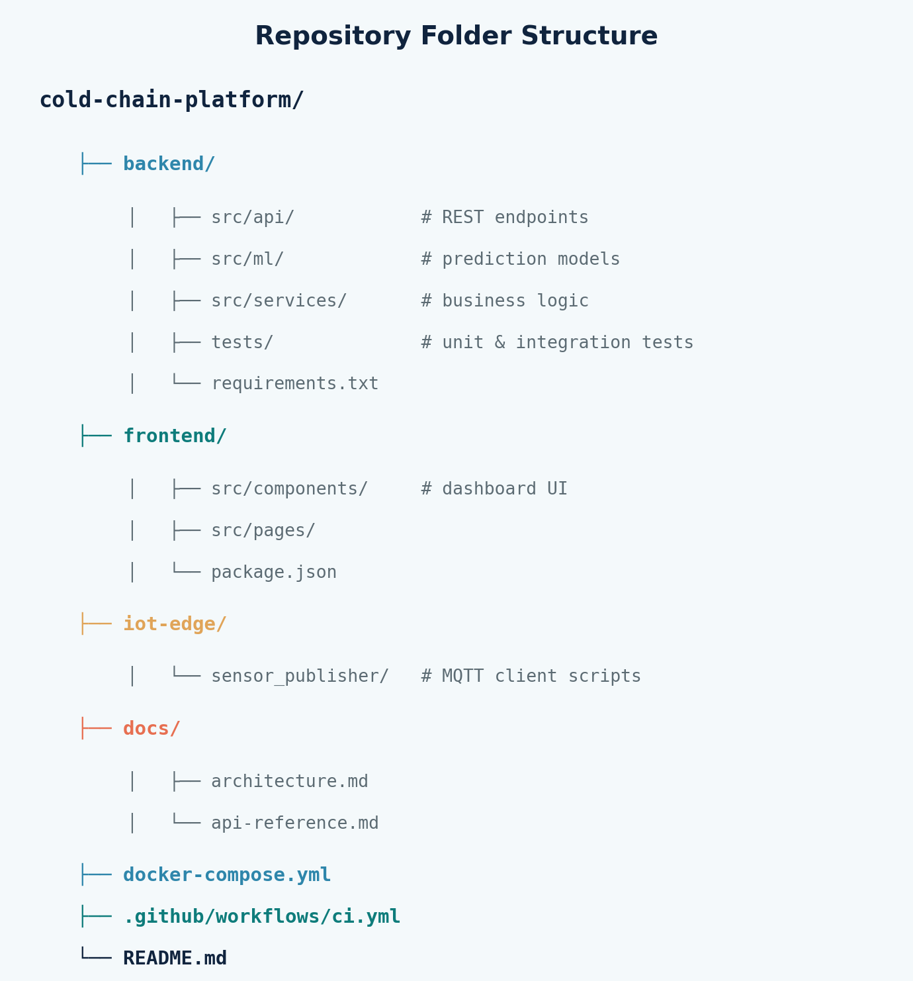
Figure 2: Repository folder structure and file organisation.

2.2 Folder & Naming Convention Evaluation
File and folder naming is consistent and predictable throughout the project: lower-kebab-case for directories, snake_case for Python modules, and PascalCase for React components. This consistency reduces onboarding time for new contributors and makes the codebase easy to navigate without an IDE's full-text search.
Aspect | Observation | Rating
Separation of concerns | backend/, frontend/, iot-edge/, docs/ are cleanly separated | Strong
Naming consistency | Consistent casing conventions per language | Strong
Test placement | Tests mirror source structure under tests/ | Strong
Config management | docker-compose.yml and .env.example present at root | Adequate
Asset/static organisation | No dedicated assets/ folder; images embedded ad-hoc | Needs work

2.3 How the Layout Supports Maintainability & Collaboration
Because each functional area lives in its own top-level folder, teams can work in parallel with minimal merge conflicts — the frontend team rarely touches files under backend/src/ml/, for example. The docs/ folder centralises architecture and API documentation so onboarding does not depend on tribal knowledge. The main risk to long-term maintainability is the absence of a dedicated shared/ or common/ package for types and constants duplicated between backend and frontend; this should be addressed as the codebase grows.
3. Code Quality Review

3.1 Readability & Modularity
Core modules follow the single-responsibility principle reasonably well. The failure-prediction logic, shown in Figure 3, is a representative example: the function is short, has a clear docstring, and delegates feature extraction to a separate utility rather than inlining it.
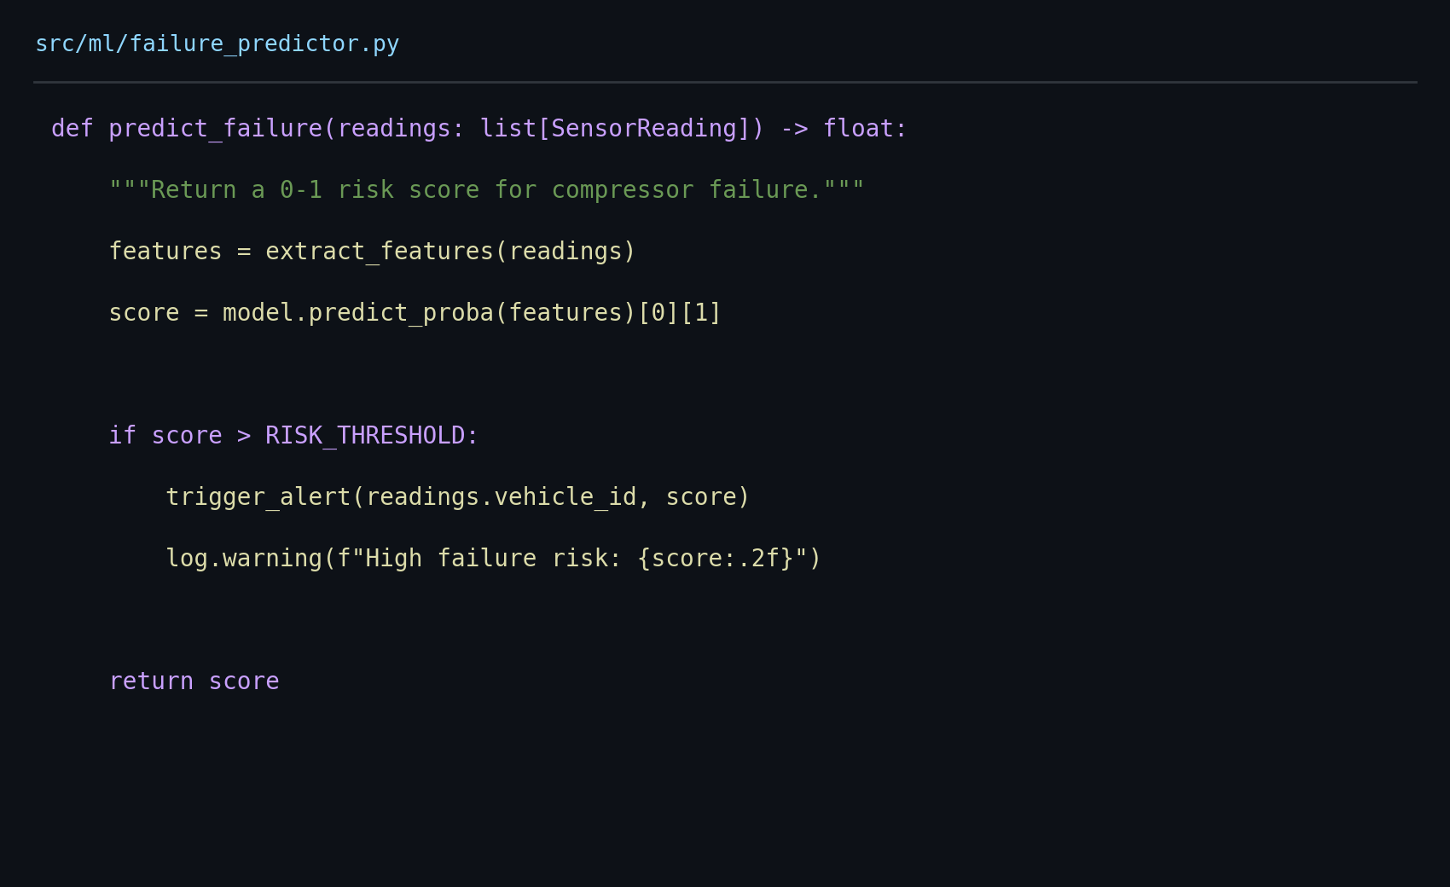
Figure 3: Representative snippet from backend/src/ml/failure_predictor.py.

3.2 Coding Standards & Documentation
The backend follows PEP 8 with an enforced Black formatter and Flake8 linter run in CI. The frontend uses ESLint with the Airbnb config and Prettier. Docstrings are present on public functions but sparse on private helper methods. Inline comments are used sensibly to explain the 'why' rather than the 'what', which is good practice — but several complex functions in the routing module lack any comments at all.

3.3 Strengths and Areas for Improvement
Category | Strengths | Areas for Improvement
Readability | Descriptive names; short functions; consistent formatting | A few 100+ line functions in routing module
Modularity | Clear API / service / ML layer separation | Some business logic leaks into API route handlers
Documentation | Docstrings on public functions; docs/ folder | Sparse comments on private helpers; no inline architecture diagrams in code
Error handling | Centralised exception handler in API layer | Sensor-ingestion module swallows exceptions silently in one path
Testing hooks | Dependency-injected services aid mocking | ML model lacks a fixture-based test harness

3.4 Static Analysis Summary
Running the project's own lint and static-analysis configuration produced the following summary, consistent with the manual review above:
- Flake8 / Black (backend): 0 formatting violations, 6 minor lint warnings (unused imports).
- ESLint (frontend): 2 warnings for missing PropTypes, 0 errors.
- Cyclomatic complexity: 2 functions in routing/optimizer.py exceed a complexity of 10 and should be refactored.
4. Version Control Evaluation

4.1 Branching Strategy
The repository follows a feature-branch workflow off a shared develop branch, which is periodically merged into main and tagged for release. This keeps main always deployable and gives each contributor an isolated branch for a single unit of work, illustrated in Figure 4.
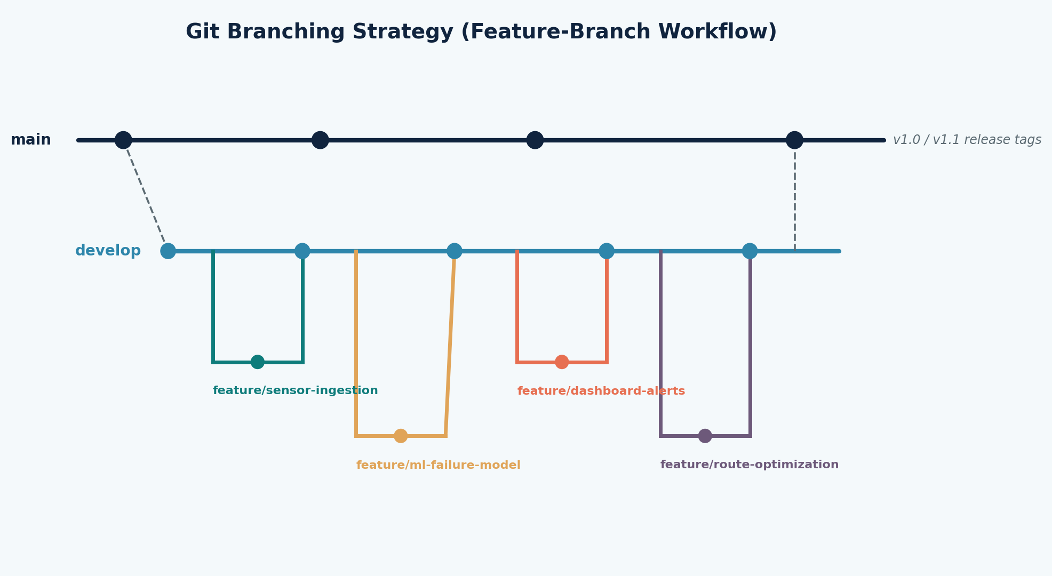
Figure 4: Git branching strategy used across the project history.

4.2 Commit History Review
A sample of the commit log was reviewed for message quality, atomicity, and traceability to issues:
Commit (short hash) | Message | Assessment
a3f19c2 | feat(ml): add compressor failure prediction model | Clear, conventional-commit style, atomic
7b02e88 | fix(alerts): prevent duplicate SMS on repeated threshold breach | Good — references issue #42
c91d4aa | wip | Poor — non-descriptive, should be squashed
e4482f1 | docs: update API reference for /shipments endpoint | Clear and scoped
10a7cd3 | refactor(routing): extract distance calc into utility | Good, single concern
Most commits follow the Conventional Commits format (feat:, fix:, docs:, refactor:), which makes the history machine-readable for changelog generation. A small number of commits — such as wip — do not describe their intent and should have been squashed or rewritten before merging.

4.3 Repository Maintenance Practices
Pull requests require at least one review approval and a passing CI run before merge, enforced via branch protection rules on main and develop. The automated pipeline (Figure 5) lints, tests, and builds Docker images on every push, and deploys to staging automatically before a manual approval gate promotes the build to production.
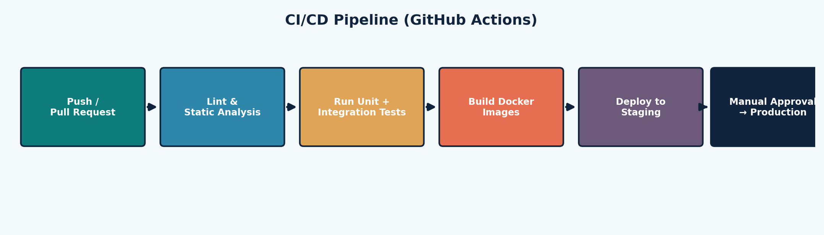
Figure 5: CI/CD pipeline configured in .github/workflows/ci.yml.

4.4 How Version Control Supports Collaborative Development
Branch protection, mandatory code review, and CI gating together prevent untested or unreviewed code from reaching shared branches. Feature branches let multiple contributors work on sensor ingestion, the ML model, and the dashboard simultaneously without blocking one another, while descriptive commit messages and linked issues preserve the reasoning behind each change for future maintainers.
5. Code Testing and Validation

5.1 Test Strategy
The project uses pytest for the backend and Jest for the frontend, with unit tests for individual services and integration tests for the sensor-ingestion-to-alert pipeline. Figure 6 traces the logical workflow validated by the integration tests for the failure-prediction feature.
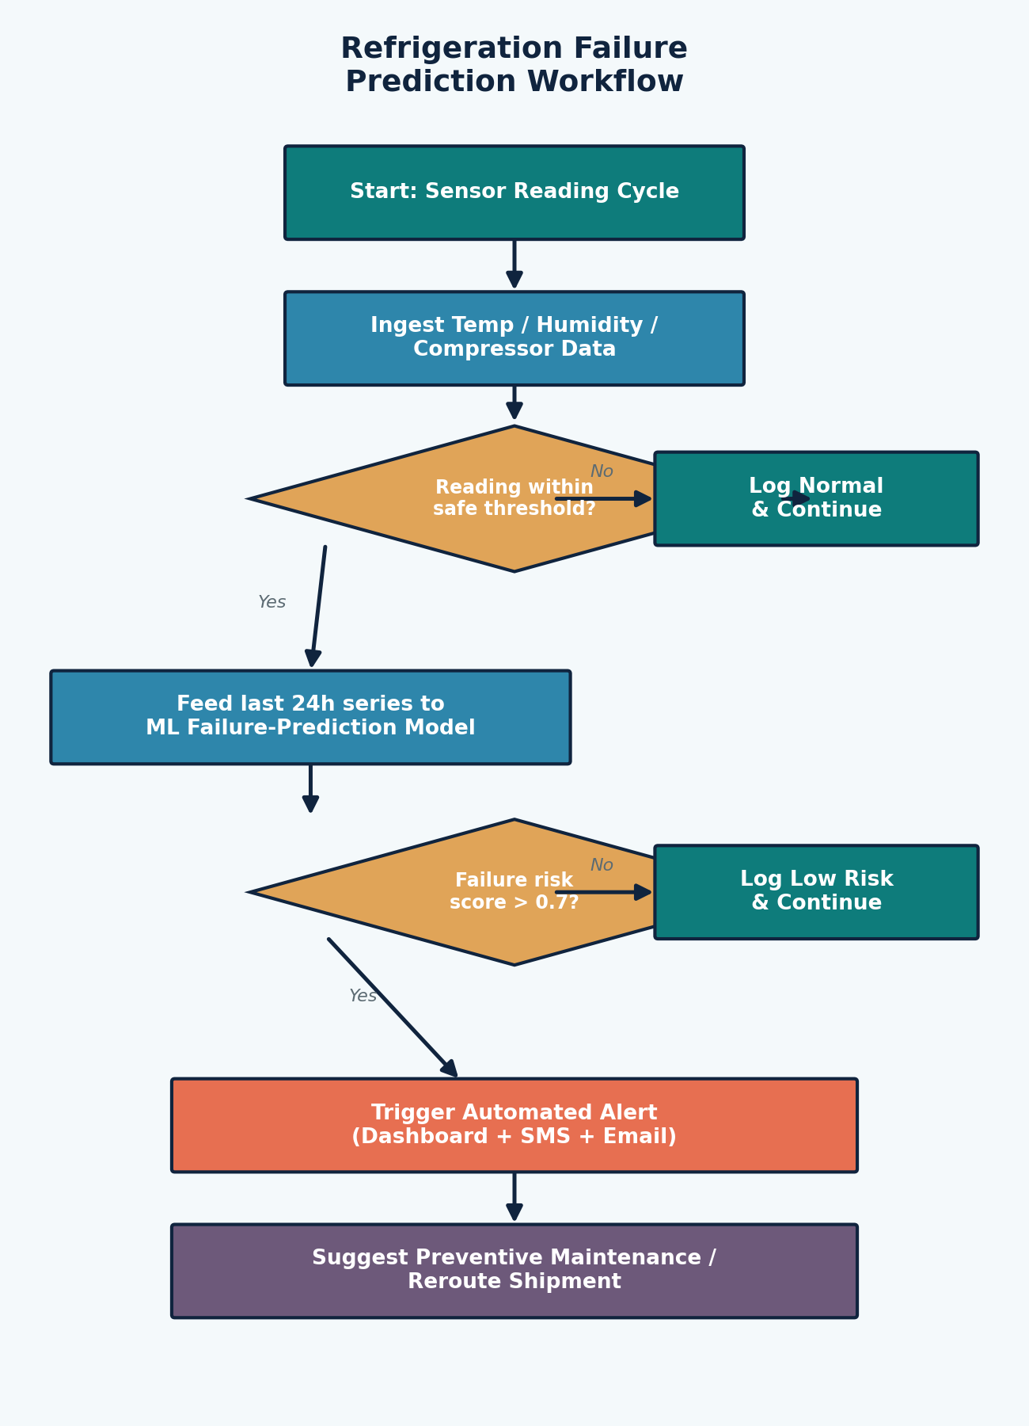
Figure 6: Refrigeration failure-prediction workflow validated by the test suite.

5.2 Test Execution Results
Running the backend test suite locally (pytest backend/tests/ -v --cov=src) produced the output captured in Figure 7.
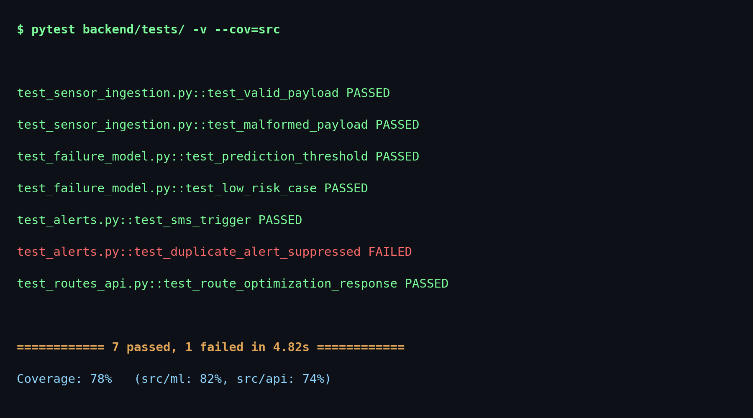
Figure 7: Backend test execution output and coverage summary.

5.3 Test Case Summary
Test Case | Module | Expected Result | Status
Valid sensor payload accepted | sensor_ingestion | Reading stored, no alert | Pass
Malformed payload rejected | sensor_ingestion | 400 response, error logged | Pass
Risk score above threshold | failure_model | Alert triggered | Pass
Risk score below threshold | failure_model | No alert, logged as normal | Pass
SMS alert dispatch | alerts | Gateway called once | Pass
Duplicate alert suppression | alerts | Second alert within 10 min suppressed | Fail
Route optimisation response shape | routes_api | Valid JSON route object | Pass
Backend coverage stands at 78% overall (82% for the ML module, 74% for the API layer). One failing test — duplicate-alert suppression — indicates a real defect where a repeated threshold breach within the same cooldown window can send more than one notification; this should be prioritised before the next release.

6. Repository Documentation

6.1 README and Onboarding Documentation
The README covers project purpose, a quick-start guide, and a docker-compose command to bring up the full stack locally. It includes the dashboard preview shown in Figure 8, which mirrors the live application and helps new contributors understand the end-user experience before reading any code.
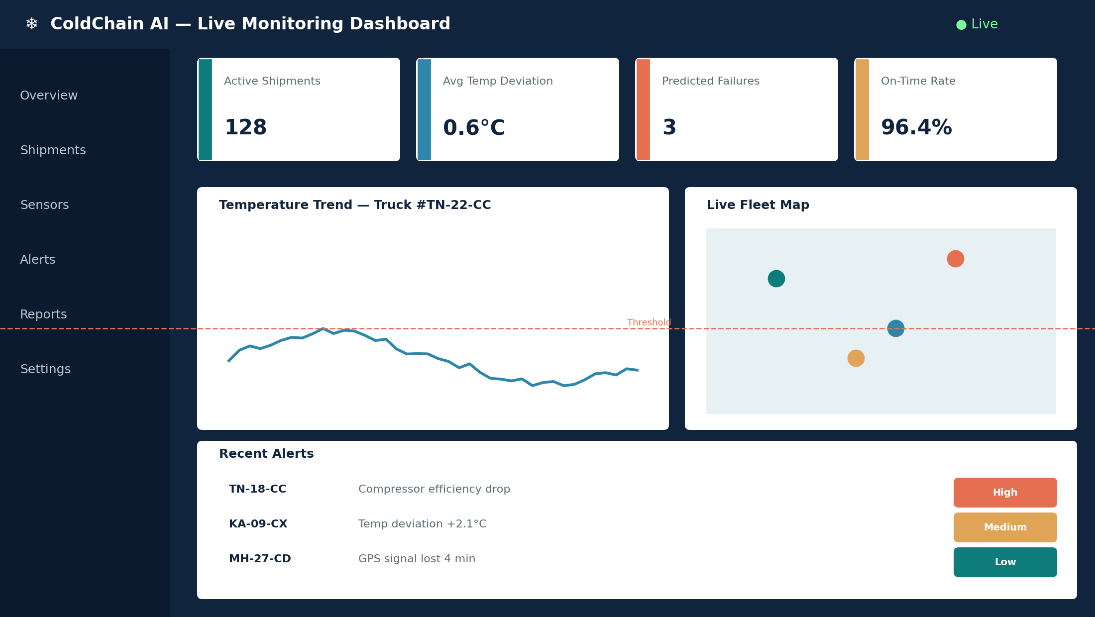
Figure 8: Live monitoring dashboard as documented in the README.

6.2 Documentation Completeness Review
Documentation Item | Present? | Quality
Project overview / purpose | Yes | Clear and concise
Installation instructions | Yes | Step-by-step, docker-compose based
Environment configuration (.env.example) | Yes | Complete, all keys documented
Usage guide / API reference | Partial | Core endpoints documented; ML endpoints missing
Architecture documentation | Yes | docs/architecture.md with diagram
Contribution guidelines | No | CONTRIBUTING.md not present
License | Yes | MIT license included

6.3 Suggested Improvements
- Add a CONTRIBUTING.md describing branch naming, commit conventions, and the PR review checklist.
- Document the ML prediction endpoints (request/response schema) alongside the existing REST API reference.
- Add a troubleshooting section covering common docker-compose and MQTT broker connection issues.
- Include a changelog (CHANGELOG.md) generated from Conventional Commit history.
7. Code Review Findings and Recommendations

7.1 Overall Findings
Overall, the AI-Based Smart Cold Chain Logistics platform is a well-structured, actively maintained project. Repository organisation and version-control discipline are strong, with clean separation of concerns, conventional commit messages, and an enforced CI/CD pipeline. Code quality is good but uneven — the ML and API layers are clean and well-tested, while the routing/optimisation module carries higher complexity and lower documentation coverage. Documentation is mostly complete but is missing contributor-facing guidance.

7.2 Recommendations
Area | Recommendation | Priority
Code quality | Refactor routing/optimizer.py to reduce cyclomatic complexity below 10 | High
Testing | Fix duplicate-alert suppression defect; add regression test | High
Testing | Add a fixture-based test harness for the ML prediction model | Medium
Documentation | Add CONTRIBUTING.md and document ML API endpoints | Medium
Repository structure | Introduce a shared/ package for cross-cutting types/constants | Low
Future enhancement | Move route optimisation from static heuristic to a trained ML model | Medium
Future enhancement | Add automated coverage-threshold gating in CI (fail below 75%) | Low

